**Attendance Reports in Microsoft Teams**

In the browser

1. Click on the people icon.



1. Next to the word People are three dots. Click on the three dots. Choose download attendance.

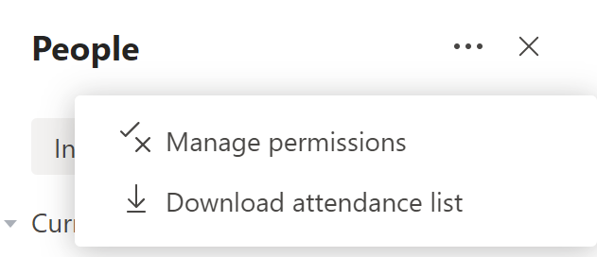

1. From downloads open the Excel file to view the attendance report.

