**Attendance Reports in Microsoft Teams**

In the desktop

1. Click on the people icon.

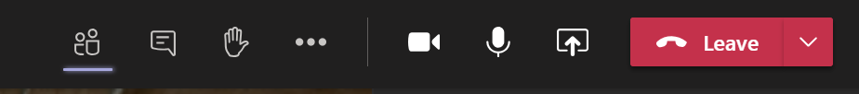

1. Next to the word Participants are three dots. Click on the three dots. Choose download attendance.

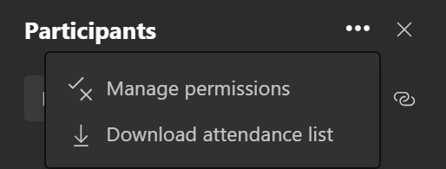

1. From downloads open the Excel file to view the attendance report.

