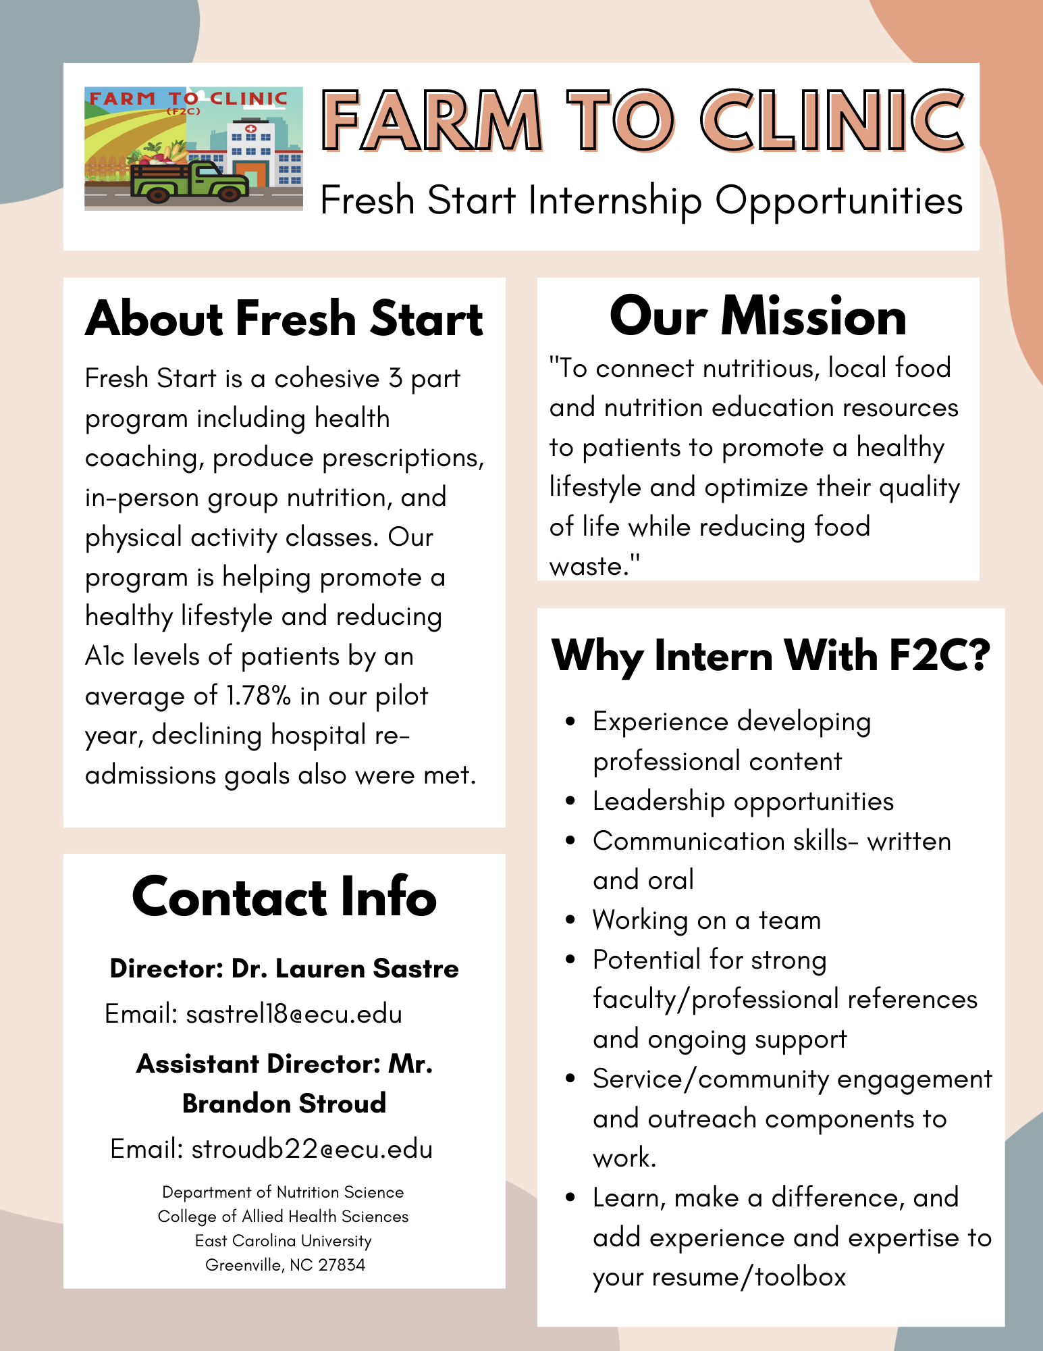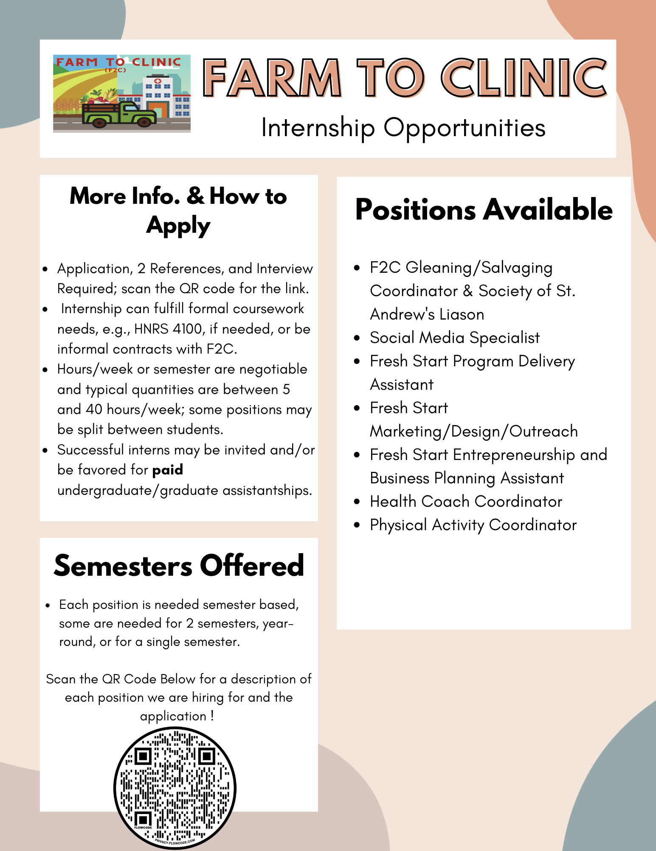

**What could you be involved in?**

**Farm to Clinic Food Recovery**: Direct food recovery in collaboration with local farms to harvest/collect/gather locally grown donated produce that will be packaged and connected with under-resourced, food insecure patients. The food is used to provide a “PRx” – a produce prescription to patients to compliment their medical care and treatment and ensure access to fresh healthy food within the Fresh Start program.

**Fresh Start:** The Fresh Start program is a **mobile, rural health program that works across Eastern North Carolina to address diabetes related health disparities.** The program is delivered annually January-May to uninsured, low-income patients who receive care at free and charitable clinic members of the North Carolina Association of Free and Charitable Clinics. **Fresh Start offers patients: 1) a fresh produce Rx, 2) group classes with cooking, physical activity and nutrition and health education as well as a 1 on 1 health coach**. We work across eastern NC with clinics, farms, and churches.

**You could be involved:** helping to develop program/class content, deliver and evaluate the classes and overall program’s effectiveness. There are opportunities to provide education and support with cooking, nutrition and health education and physical activity directly with patients. You could assist with general and social media content development and management, and more!



**Apply Here:**

[https://forms.gle/qsrBr3xVJf2P9HcE9](https://nam02.safelinks.protection.outlook.com/?url=https%3A%2F%2Fforms.gle%2FqsrBr3xVJf2P9HcE9&data=05%7C01%7CSASTREL18%40ECU.EDU%7C38ada06cc1d749a3ff9708daa61a4ca6%7C17143cbb385c4c45a36ac65b72e3eae8%7C0%7C0%7C638004929123983257%7CUnknown%7CTWFpbGZsb3d8eyJWIjoiMC4wLjAwMDAiLCJQIjoiV2luMzIiLCJBTiI6Ik1haWwiLCJXVCI6Mn0%3D%7C3000%7C%7C%7C&sdata=K4M6iu3UwX5ZKPJBEpwue1BV0CUnQbtQHdN4y4rBESU%3D&reserved=0)

