Take a Photo Here
Images from Instagram: The stairwell at the New Museum in New York.CreditClockwise from top left: Mark Lo Sasso; Daniel Gussack; Melody Mo; Susan MacDonald; Patricia Lindberg; John Queyquep.
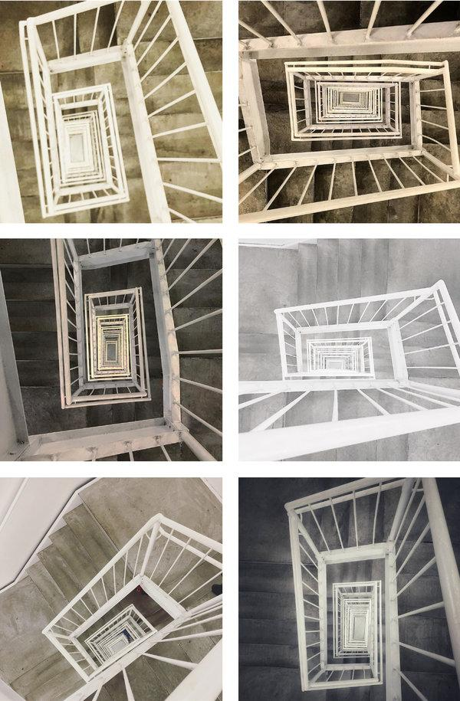
By Teju Cole on June 27, 2018
We carry the cameras built into our phones around all the time, and the resulting flood of images says something about what people, in the aggregate, like to photograph. There are sunsets, meals, selfies, babies, dogs from dog people, cats by cat persons. There are distinctly contemporary ways of taking pictures at a party or of photographing landscapes. Originality, always hard to come by, is getting harder.
A traveler, to preserve memories, could make drawings of a destination or record its ambient sound. But for most of us, the way to capture a place is through photography. What this means is that travel gradually becomes synonymous with taking photographs, photographs that are duly shared on social media. And if you study those photos, you might realize something peculiar: People don’t merely go to the same places or take photographs of the same monuments and sites; they take photographs of the same monuments and sites in the same way. This applies to tourist sites, public spaces and ordinary buildings. The same gestures and vantage points and compositions are repeated, and the images come out so uncannily similar that it’s as though everyone were subject to the same set of instructions.
In a sense, they are. A monument like the Statue of Liberty has an obvious front. For many tourists, a photo of the front of the statue taken from a boat is the ideal view. There will be many more photos of that view on Instagram than of secondary views from the side or the back. But what happens at a more complex site like the Roman Forum, for instance? On a visit to Rome last year, I found myself trawling Instagram for pictures of the Forum. I’d already got into the habit of looking up places with the goal of understanding how they were being photographed by tourists. I looked at Gullfoss waterfall in Iceland, which I had never visited, and Columbus Circle in New York, which I had. I built up a small archive of images found on Instagram that revealed the curious limitations of tourist engagement with terrain. What was odd about my study of the Roman Forum was that I was doing it while sitting in a hotel room in Rome. I was visiting the Forum through other people’s eyes instead of going there myself.
The Roman Forum was the center of public life in ancient Rome. Its gargantuan temples and superb civic buildings, almost all in ruins now, contain so much archaeological information scattered over so many acres that, logically, there is no single ideal place from which to view them. Why, then, was I finding numerous photographs that showed one predominant view? In that view, the three remaining columns of the Temple of Castor and Pollux were just left of center in the foreground, the relatively small Temple of Vesta was on the right foreground, the Arch of Septimius Severus was behind them in the middle distance, and way in the background at the left were the Capitoline Hill and the massive 19th-century monument to Vittorio Emanuele II. Within 30 minutes of scrolling through Instagram, I found nine photos containing these monuments, all in the same arrangement relative to one another, all seemingly photographed from the same spot.
Images from Instagram: The Roman Forum.CreditClockwise from top left: Jenny Barrow; Nikol Skorpikova; Jessica Duckenfield; Sophie Takessian; Lloyd Tee Sze Hou; Hayley McColl.
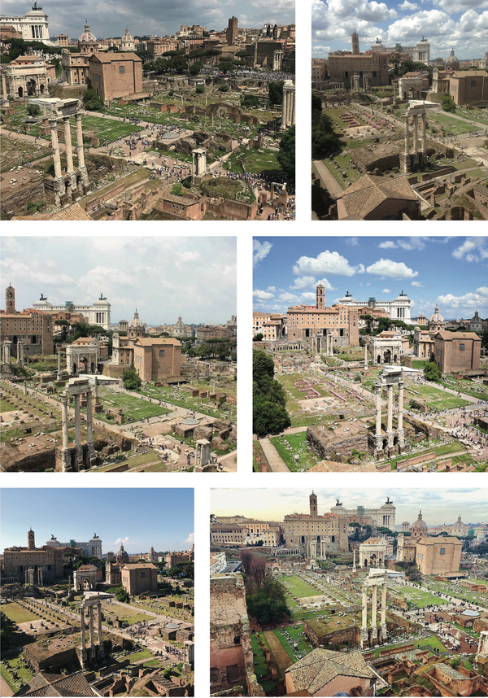
A combination of factors is at play in these uncanny repetitions. There is the native inclination we all have toward the picturesque: We like to keep the horizon line level, we are drawn to natural spectacle, famous pictures or impressive ruins and we love visual rhythm of a certain kind: symmetry, spirals, curves and converging lines. Standing in a given position, we tend to seek out these cadences. There is also the fact that many of the photographs shared on social media are made with the cameras on mobile phones, most of which are automatically set to shoot in color, at a wide angle and with similar dynamic contrasts. But, most crucial, there are features of any given site that work directly and indirectly on the visitor to suggest optimal viewpoints and therefore optimal photographic angles.
Looking at the photographs of the Roman Forum, I could guess that there was probably a promontory somewhere southeast of the site that enabled you to look down into the Forum and in a northwesterly direction. Probably there was a ticketing booth, then a path leading up to a rise and then some kind of rail or barrier, which established the limit of how close people could come to the ruins. People were probably leaning over this barrier to get the ideal photograph, the one I had been seeing in multiplicate.
Theorists have long grappled ith the question of how individual walkers interact with public space. According to V.Y. Mudimbe, “A street is a place that a walker transforms into an active space.” Michel de Certeau, earlier, wrote that “a spatial order organizes an ensemble of possibilities (e.g., by a place in which one can move) and interdictions (e.g., by a wall that prevents one from going further).” These possibilities and interdictions seem to be especially present when the space in question is a tourist site. Views are arranged through turnstiles, paths, guardrails, signs and walls. A visitor might think she’s simply experiencing a set of archaeological ruins or a natural feature of the landscape, but she is in fact subject to whatever the tourist board, landscape designer or architect has prepared for her. This preparation of the site has a major but often unnoticed influence on the photos she might end up taking at the site.
The day after I explored the Roman Forum online, I visited it in person. I was just as interested in the ruins as in confirming my intuition about the organization of the site. And it had been “archaeologized” in just the way I guessed. When you enter the site, coming in through gates at the Colosseum end of the Forum, a path leads you left, then up a flight of stairs, then farther up, to a restricted promontory, for a northwest view toward the Capitoline Hill. Up on the promontory, I could see people taking the photographs they would later post on social media.
A site ought in theory to make possible a large number of vantage points. In reality, only a few points of view account for the majority of photographs made. The visitor to a place like the Roman Forum does not only take a photograph of the Forum; he also takes a photograph for the Forum. His photograph partly serves the narrative chosen by the Forum’s custodians. The visitor is inadvertently mesmerized not only by the site but also by the municipal or museological organization of the experience of the site.
The technological concept of “affordance,” often applied to devices or tools, might be a helpful way for thinking about how such sites can act on us. The term was coined in the 1960s by the perceptual psychologist James J. Gibson and has since been given two related but distinct definitions. One definition, derived from the work of the cognitive scientist Don Norman, is that “affordances provide strong clues to the operations of things.” A drawer handle is for pulling, a bag is for putting things into and a chair is for sitting. Affordances are what let us know an object’s purpose. The other definition comes from the computer scientists Joanna McGrenere and Wayne Ho, who argued that Gibson’s idea of affordance was “an action possibility available in the environment to an individual, independent of the individual’s ability to perceive this possibility.” I think both definitions apply to how tourist spaces act on us: The effects are both intentional “strong clues” and inadvertent “action possibilities.”
Photography on social media, if you know where to look, can astonish with its hypnotic stream of inexact repetitions. We think we are moving through the world, while the whole time the world is pulling us along, telling us where to walk, where to stop, where to take a photo. Why have so many people looked straight down a stairwell at the New Museum and taken a photograph there? Each person who does it feels a frisson of originality but unknowingly reveals something that was latent in the stairwell all along.
The resultant images are rarely individually “great.” What they offer, as a sequence or as a grid, is a fleeting form of poetry: the poignant commonality of our eyes. The world individually mesmerizes us toward reiteration. Our coincident gazes overlay the same sites over and over and over again, as though we were caught up in a slow-motion religious fervor. Through the affordances of terrain, we are alleviated of the burden of originality without always being aware that we are being unoriginal. Take a photo here, the site whispers. It’s yours, but not yours alone.
Teju Cole is a novelist, a photographer and the magazine’s photography critic. His most recent book is “Blind Spot.”
A version of this article appears in print on July 1, 2018, on Page 14 of the Sunday Magazine with the headline: Take a Photo Here. Order Reprints | Today’s Paper | Subscribe

https://www.nytimes.com/2018/06/27/magazine/take-a-photo-here.html

