Hello, 2201ers.

Here it is: the final portfolio. This file will tell you how to submit it on Blackboard. Remember that you'll also need to submit it on iWebfolio (and give me permission to look at it there). For instructions on how to use iWebfolio, click here: http://www.ecu.edu/qep/ .

Meanwhile, here's how to deal with Blackboard (which is more important, really, in that I can't grade your portfolio if you don't do all this stuff):

• Go to the Blackboard homepage for your ENGL 2201 Course.

• On the left-hand side of Bb, open “Portfolio and Self-Analytical Writing.”

(You have the option of taking a video tour that can be found in this section.)

• Open “Final Portfolio.”

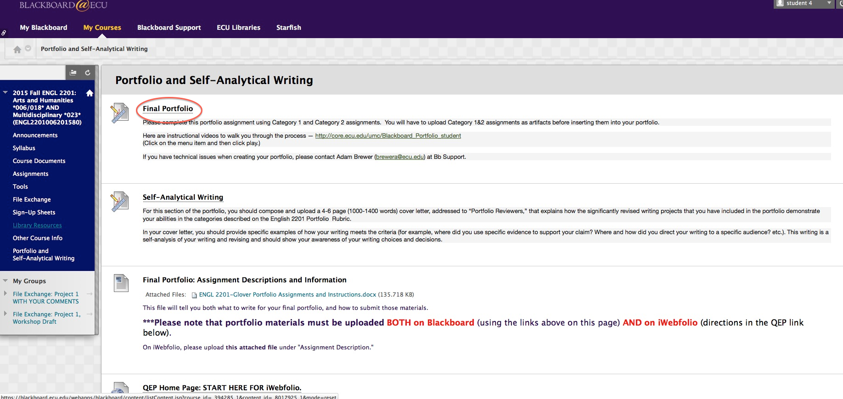

• Create portfolio, naming it "ENGL 2201 final portfolio Spring 2016."

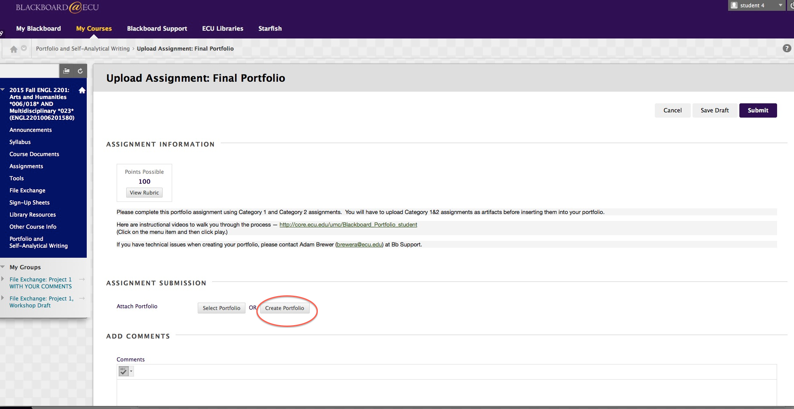

NOTE: I have NOT created a template. Don't bother with that button.
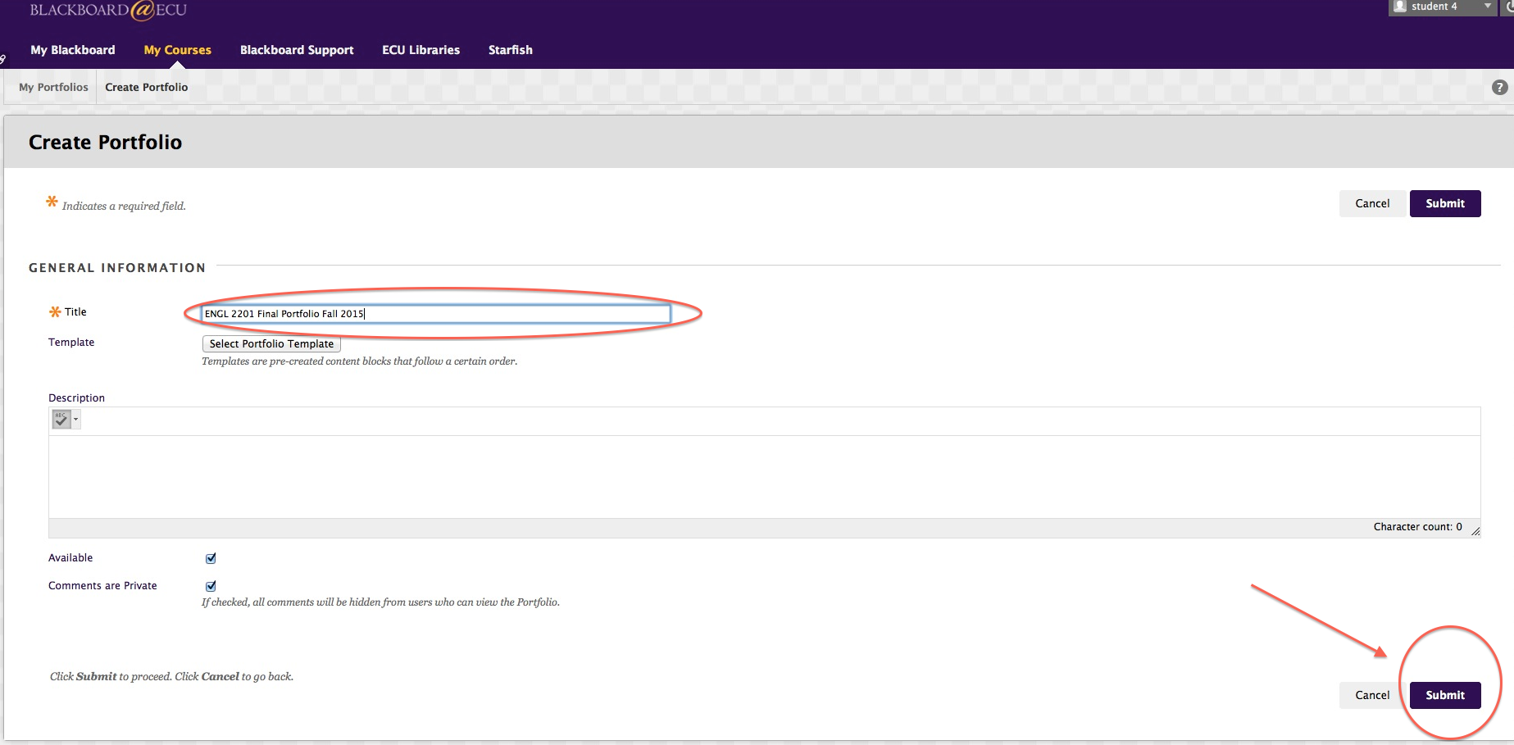

• Don’t worry about writing a description. Hit "Submit."

• Decline the tour.
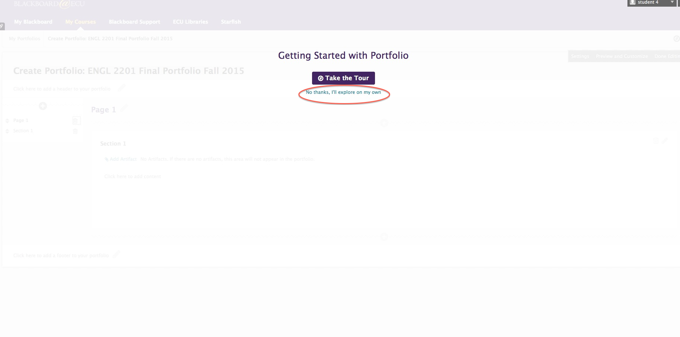

OK. Take a deep breath. Let’s add artifacts.

• Click on “Add Artifact.”
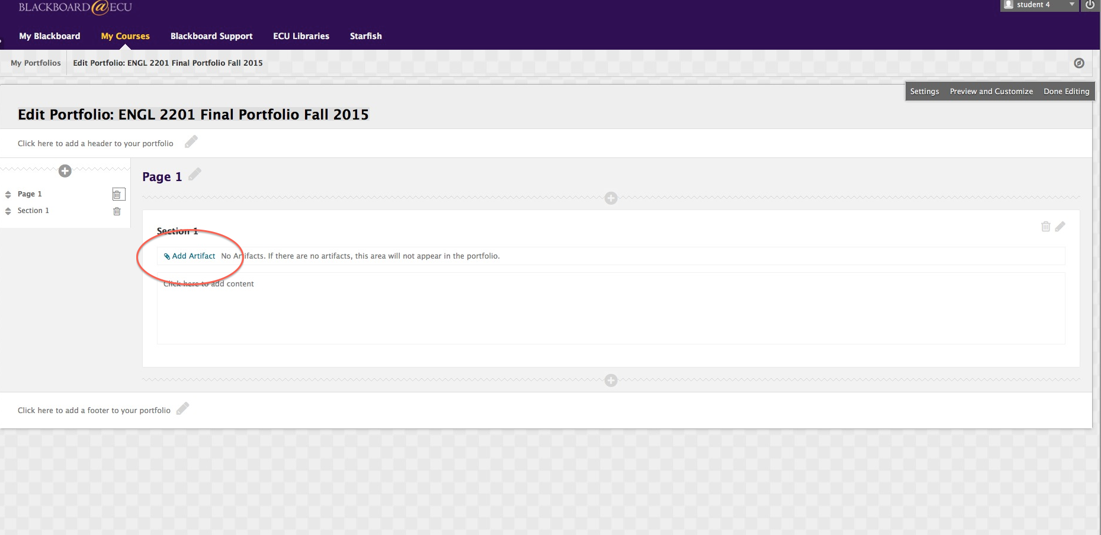

• Now, click on “Add Personal Artifact”

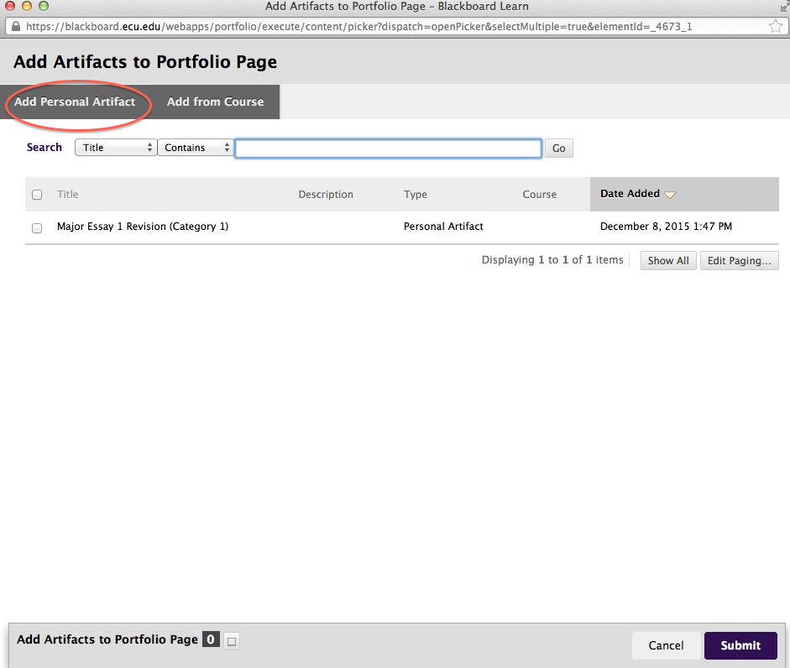

• Upload the two revised documents from your own computer: one of the two major essays and one Category 1 assignment. Submit. You should see something like this:

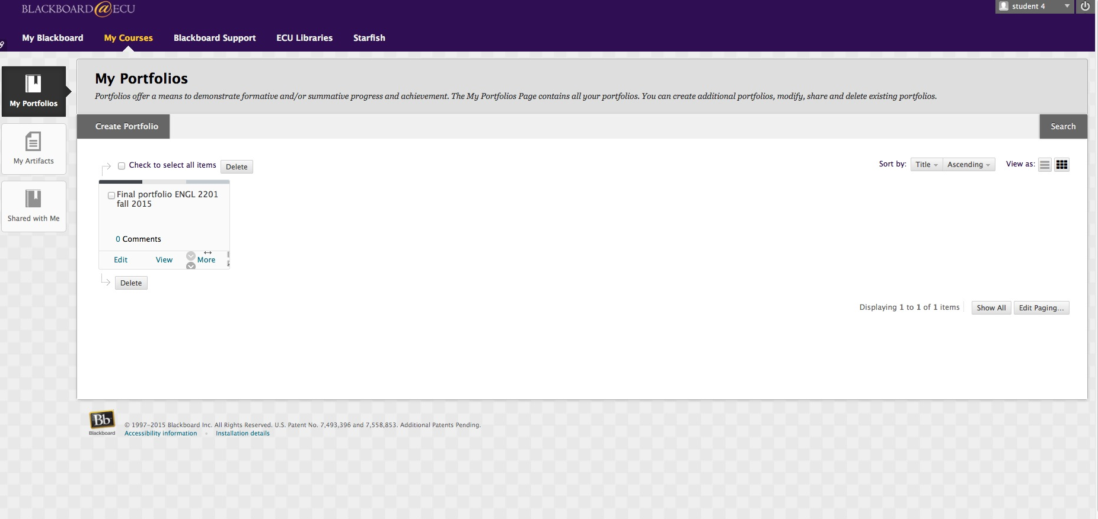

• ***Now, go back to the Blackboard home page for this course and re-open “Portfolio and Self-Analytical Writing.” Yeah, I know this seems redundant. It's crucial.

•Click on Final Portfolio. (You should see "Preview Upload Assignment: Final Portfolio.")

• Click on "Select Portfolio."
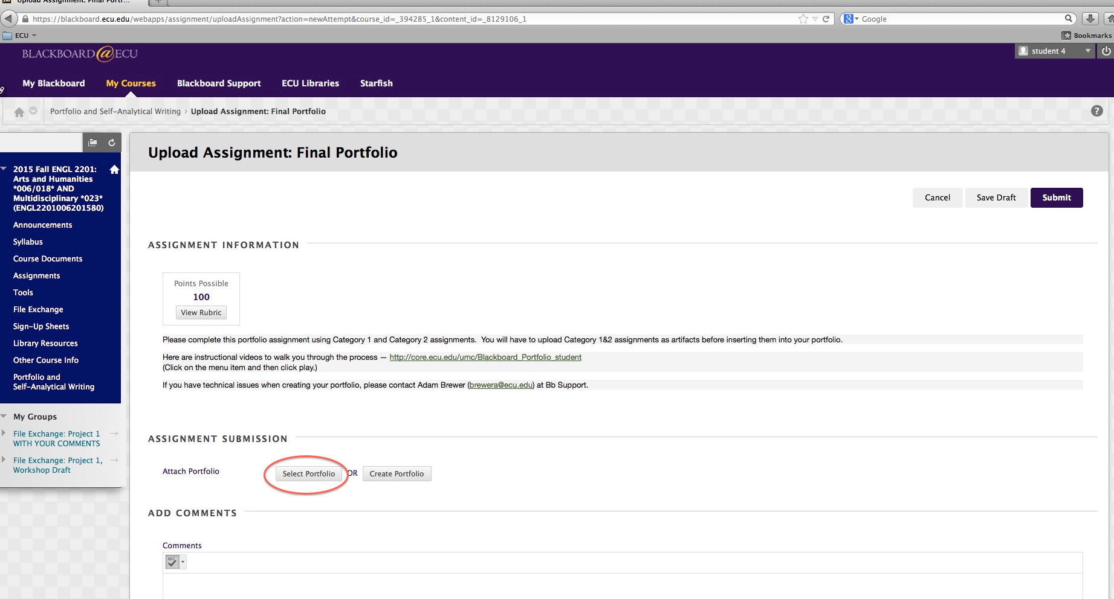

• Now, click on the title of your portfolio and hit submit.

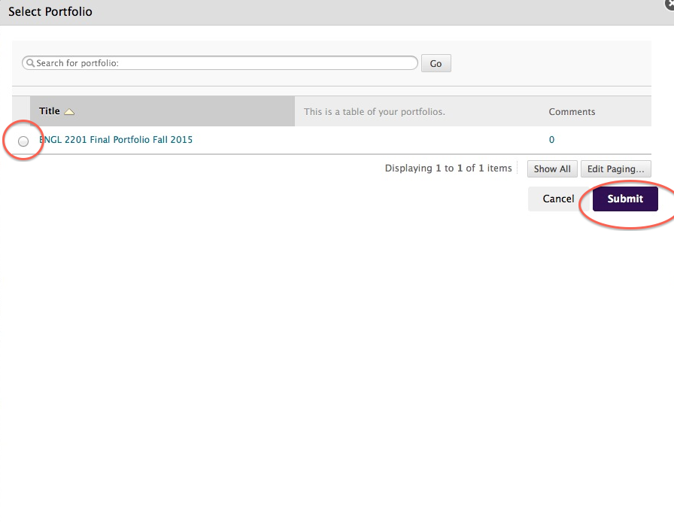

• ***Click "Submit" one last time.***

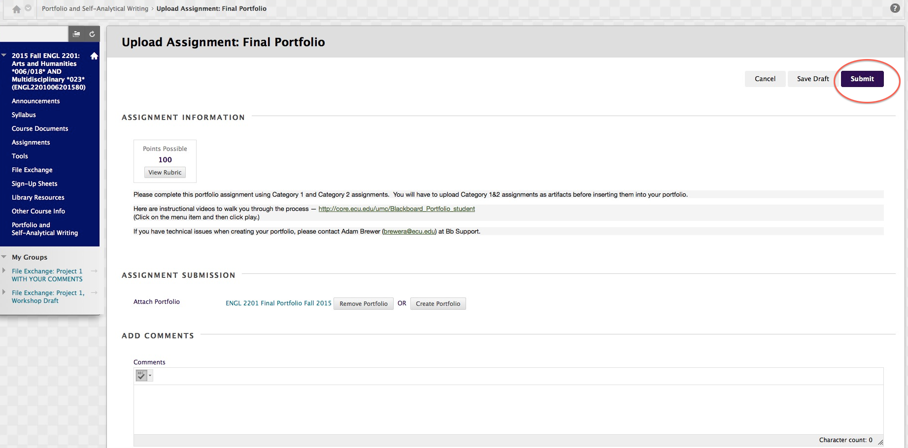

• You are almost done. Now, go back to "Portfolio and Self-Analytical Writing" and click on the “Self-Analytical Writing” section. Upload the document you wrote assessing your work. Click "Submit."

• Go back to bed. You’re done.

