Getting the Most from My Grades in Blackboard
by Ruby Nancy
East Carolina University

In My Grades, links are available to the rubric used for grading and to any feedback provided. Note the View Rubric link (circled below, in blue) and the comment bubble (also circled below).
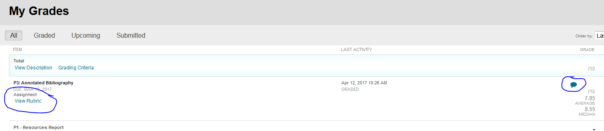
Clicking on the View Rubric link will open the Rubric Detail chart in a separate window. As you can see from the example at left, the rubric is marked to show assessment of various expectations for a particular assignment, and scores for each marking are also displayed.
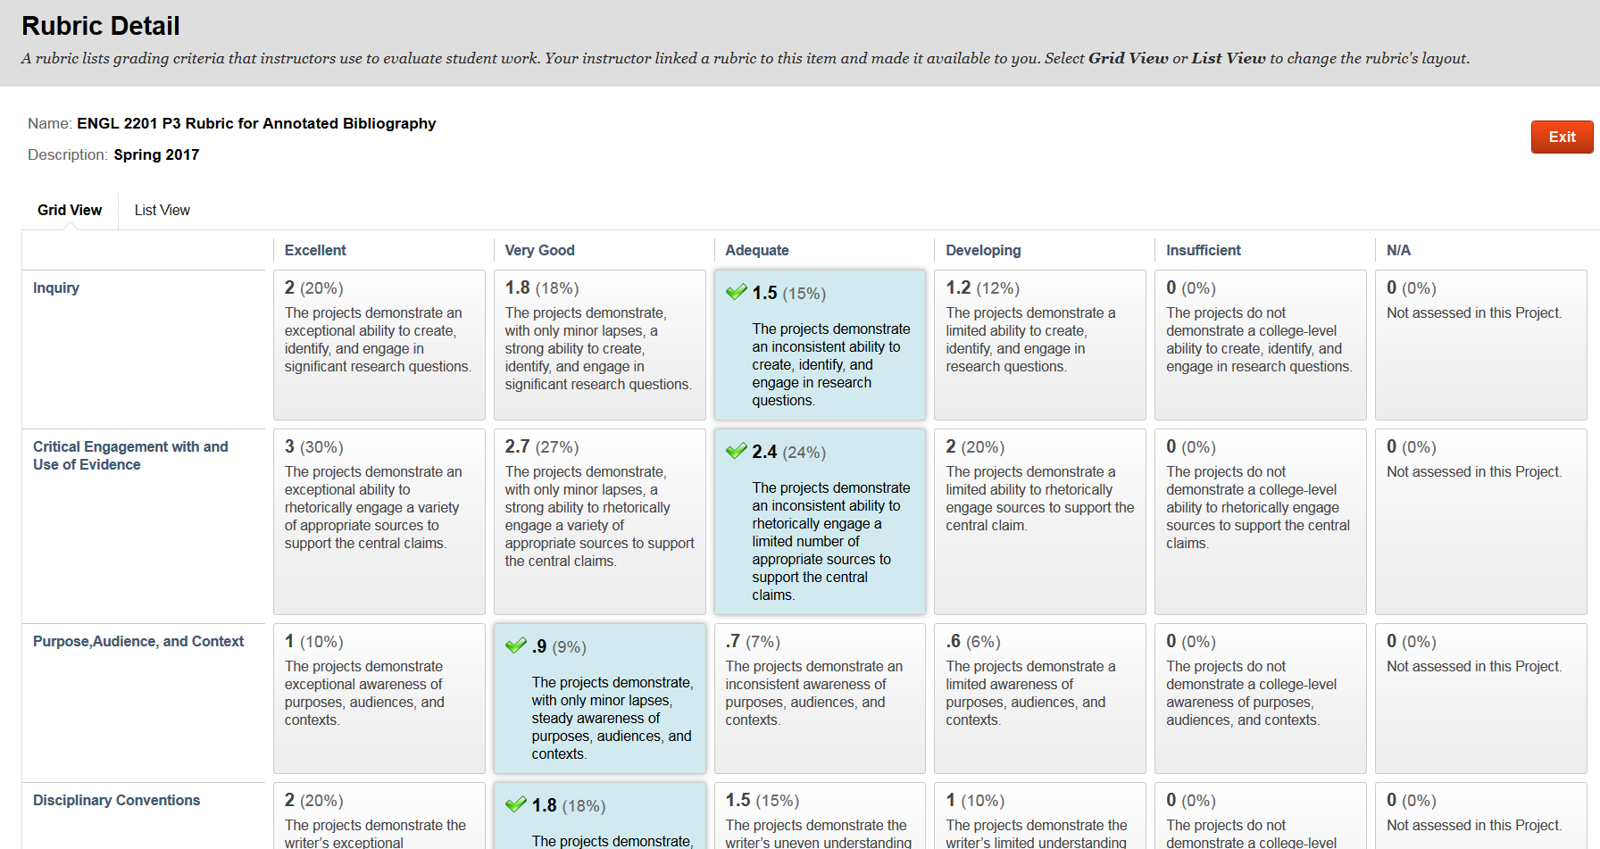
The marked squares on the rubric always provide useful feedback in sentence form, indicating your relative success meeting the goals of the assignment.

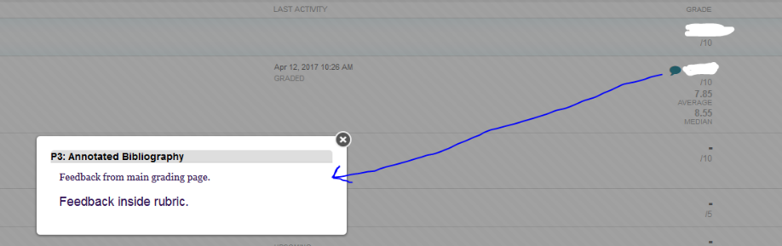
Clicking on the comment bubble opens up a comment box, which displays any feedback from instructor, whether the feedback has been entered on the main grading page or entered inside the rubric. See the screenshot example below.

Also in My Grades, even more feedback is available by clicking on the name of an assignment, which will open up the submission that has been graded.
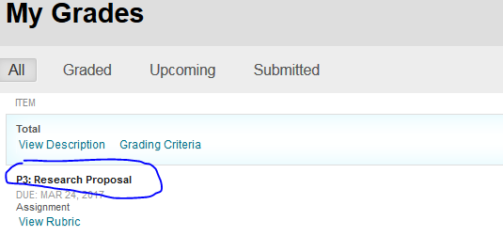

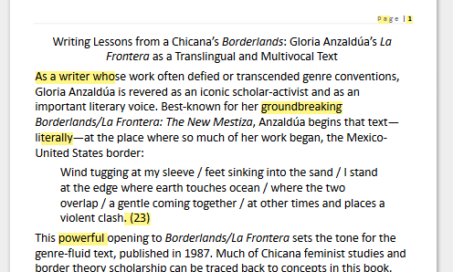
Once the assignment has been opened, you will see a ‘preview’ of the project you submitted. This version of the project will likely have yellow highlighting on it (see the sample at left). The highlighting functions as a form of feedback, in that any yellow highlighting indicates something is incorrect, incomplete, missing, formatted improperly (or formatted incompletely), or otherwise problematic.

You should examine these highlights, and if you (along with information from assigned textbooks or other provided resources) are unable to determine why something is highlighted, you should bring a printed copy of the paper to office hours and ask for clarification.

Feedback on assignments can provide clarification about why a submission earned a specific grade, but feedback is also useful for students who want to improve their writing, clear up questions about mechanics (grammar, punctuation, formatting, etc.), or earn higher grades on subsequent assignments. While some feedback, including a large portion of the yellow highlighting, may not be directly tied to grading in this course, you will encounter many other writing contexts—other courses, scholarship applications, and grad school letters, for example—where these kinds of errors can make a significant difference in terms of grades, funding, or the achievement of other goals.

